**AP DSC 2014 New Exam Pattern**

AP DSC 2014 New Exam Pattern. TET to be merged in DSC.  DSC+TET= DSC 2014. AP DSC 2014 News. AP DSC 2014 Details. **apdsc.cgg.gov.in**

**DSC 2014 New Exam Pattern:** Andhra Pradesh State government has decided to conduct a common examination instead of conducting **TET** and **DSC**examinations separately. Accordingly sources said that the new format may consist **180** questions carrying one mark each.    
  
Earlier there were two separate exams i.e **1.** **TET -** which includes topics the child development - Pedagogy, Language-I, Language-2, Maths and Environmental studies for 150 Marks. **2**. DSC for SGTs includes General Knowledge, Current Affairs, Telugu, English, 1 to 8 classes Maths, Science, Social(Content and Methodologies) for 80 marks.   
  
Presently these two different exam patterns are integrated into **a new format**. The same system has been adapted in the case of **School Assistant** Maths, Physical Sciences, Social Studies, Telugu, Hindi and English selection exam.  
  
**DSC+TET= DSC 2014** The government is planning to release the [**DSC notification**](http://chittoorbadi.weebly.com/dsc-2014-new-model-and-all-subjects-pattern.html) on September 5th and commence the sale of application forms from 16th of this month. Department of School Education is planning to conduct exam on 13, 14 and 15th of December this year and release the results by January 24th.  The dates will be confirmed after a high level review to take place in short. [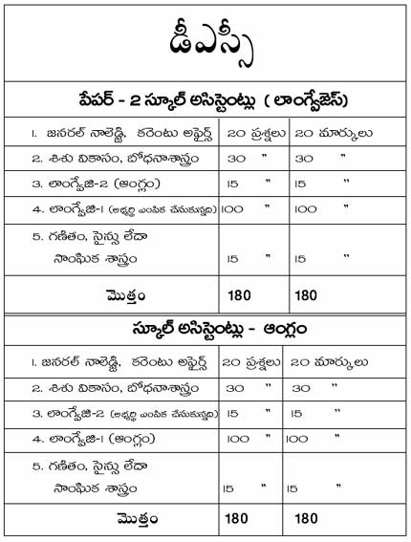](http://1.bp.blogspot.com/-NYKoPT2soRk/VAPNywkJbbI/AAAAAAAADYQ/_RI7NGh4XfY/s1600/DSC%2BSA%2BLanguages.png)n[](http://4.bp.blogspot.com/-er6rp1gxvnY/VAPNzRkmUsI/AAAAAAAADYY/B_tCeq9YdJY/s1600/DSC%2BSA%2BMaths%2Band%2BSA%2BBio.Scinec.png)

[](http://3.bp.blogspot.com/-kZMDj9SOBqA/VAPNzYgeKvI/AAAAAAAADYU/SfnIqAsKfJw/s1600/DSC%2BSA%2BPhys.png)

[](http://2.bp.blogspot.com/-tLa4NIgTTro/VAPN0i4pZaI/AAAAAAAADYo/Q1nZrOCjrrY/s1600/DSC%2BSGT%2Band%2BLPT.png)

Source : Eenadu News